Haplotype Reconstruction From SNP Alignment
Proceedings of the Seventh International Conference on Research in Computational Molecular Biology, 2003, pp.207-216
Lei Li, Jong Hyun Kim and Michael S. Waterman
Abstract
We wish to reconstruct the two haplotypes of the parents by given a set of SNP sites.
- Background
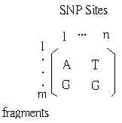
Possible haplotypes:
- AT, GG
- AG, GT

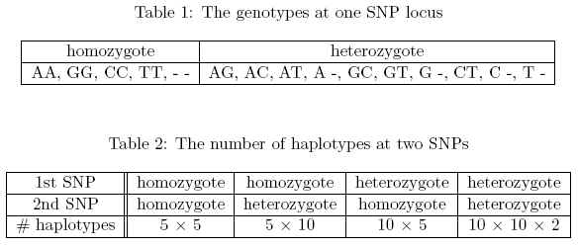
- Method
Step1. Consider all segments that cover the j-th SNP, compute the probability for all possible genotypes.

Step2. Consider the fragments that cover either the j-th or (j+1)-th SNP. Compute the probabilities respectively.
For each pair of SNPs, reports the most likely haplotype phase or leave it open based.

Step3. Link the haplotype phases and construct haplotype segment.

Setp4. Evaluate the confidence levels of haplotype segments.

Created by: Chia-Ling Sun
Date : Sept. 17, 2003

